|  |
| --- |
|  |
| MyNEU |
| Prototype Documentation |
|  |
|  |
|  |

Table of Contents

1. Pages 7

1.1. Page Tree 7

1.2. Login 8

1.2.1. User Interface 8

1.2.2. Widget Table 8

1.3. Forgot Password 9

1.3.1. User Interface 9

1.3.2. Widget Table 9

1.4. Dashboard 10

1.4.1. User Interface 10

1.4.2. Widget Table 10

1.4.3. newsPnl 11

1.4.3.1. News1 11

1.4.3.2. User Interface 11

1.4.3.3. News2 12

1.4.3.4. User Interface 12

1.4.3.5. News3 13

1.4.3.6. User Interface 13

1.5. Library - My Account 14

1.5.1. User Interface 14

1.5.2. Widget Table 14

1.6. Library - Learning Material 15

1.6.1. User Interface 15

1.6.2. Widget Table 15

1.7. Library - Reserve a Room 16

1.7.1. User Interface 16

1.7.2. Widget Table 16

1.7.3. panel - calendar 17

1.7.3.1. November 2009 17

1.7.3.2. User Interface 17

1.7.3.3. Widget Table 17

1.8. Library - Search Room 21

1.8.1. User Interface 21

1.8.2. Widget Table 21

1.9. Academics-MyGrades 22

1.9.1. User Interface 22

1.9.2. Widget Table 22

1.10. Academics-MyCourses 23

1.10.1. User Interface 23

1.10.2. Widget Table 23

1.11. Academics-Individual Course 24

1.11.1. User Interface 24

1.11.2. Widget Table 24

1.11.3. Youtube player 25

1.11.3.1. State1 25

1.11.3.2. User Interface 25

1.11.3.3. Widget Table 25

1.11.4. Media fill 26

1.11.4.1. State1 26

1.11.4.2. State2 26

1.11.4.3. User Interface 26

1.11.5. Play Pause btn1 26

1.11.5.1. State1 26

1.11.5.2. User Interface 26

1.11.5.3. State2 26

1.11.5.4. User Interface 26

1.11.6. Youtube play icon 26

1.11.6.1. State1 26

1.11.6.2. User Interface 26

1.11.6.3. Widget Table 26

1.11.7. Volume view window 27

1.11.7.1. State1 27

1.11.7.2. User Interface 27

1.11.7.3. Widget Table 27

1.11.8. Volume handle 27

1.11.8.1. State1 27

1.11.8.2. User Interface 27

1.11.9. ReadingMaterial 27

1.11.9.1. State1 27

1.11.9.2. User Interface 27

1.11.9.3. State2 27

1.11.9.4. User Interface 27

1.11.9.5. State3 28

1.11.9.6. User Interface 28

1.11.10. assignmentQuestions 28

1.11.10.1. State1 28

1.11.10.2. User Interface 28

1.11.10.3. State2 28

1.11.10.4. User Interface 28

1.11.11. Announcements 29

1.11.11.1. State1 29

1.11.11.2. User Interface 29

1.11.11.3. State2 30

1.11.11.4. User Interface 30

1.11.11.5. State3 31

1.11.11.6. User Interface 31

1.11.11.7. State4 32

1.11.11.8. User Interface 32

1.12. Academics-Transcripts 33

1.12.1. User Interface 33

1.13. Services-Parking 34

1.13.1. User Interface 34

1.13.2. Widget Table 34

1.13.3. panel - calendar 35

1.13.3.1. November 2009 35

1.13.3.2. User Interface 35

1.13.3.3. Widget Table 35

1.14. Services-Finance 39

1.14.1. User Interface 39

1.15. Services-HealthAppointment 40

1.15.1. User Interface 40

1.15.2. Widget Table 40

1.15.3. panel - calendar 42

1.15.3.1. November 2009 42

1.15.3.2. User Interface 42

1.15.3.3. Widget Table 42

1.16. Dashboard v2 46

1.16.1. User Interface 46

1.16.2. Widget Table 46

1.16.3. newsPnl 47

1.16.3.1. News1 47

1.16.3.2. User Interface 47

1.16.3.3. News2 48

1.16.3.4. User Interface 48

1.16.3.5. News3 49

1.16.3.6. User Interface 49

1.17. Page 3 50

1.17.1. User Interface 50

2. Masters 51

2.1. Master List 51

2.2. Header 52

2.2.1. User Interface 52

2.2.2. Widget Table 52

2.3. Main Menu 53

2.3.1. User Interface 53

2.3.2. Widget Table 53

2.4. Submit Button 55

2.4.1. User Interface 55

2.5. Footer 56

2.5.1. User Interface 56

2.6. Tile 57

2.6.1. User Interface 57

2.7. Back Button 58

2.7.1. User Interface 58

2.7.2. Widget Table 58

2.8. SearchRoomDialog 59

2.8.1. User Interface 59

2.8.2. Widget Table 59

1. Pages
   1. Page Tree

Login  
 Forgot Password  
 Dashboard  
 Library  
 Library - My Account  
 Library - Learning Material  
 Library - Reserve a Room  
 Library - Search Room  
 Courses  
 Academics-MyGrades  
 Academics-MyCourses  
 Academics-Individual Course  
 Academics-Transcripts  
 Services  
 Services-Parking  
 Services-Finance  
 Services-HealthAppointment  
 Dashboard v2  
 Page 3

* 1. Login
     1. User Interface

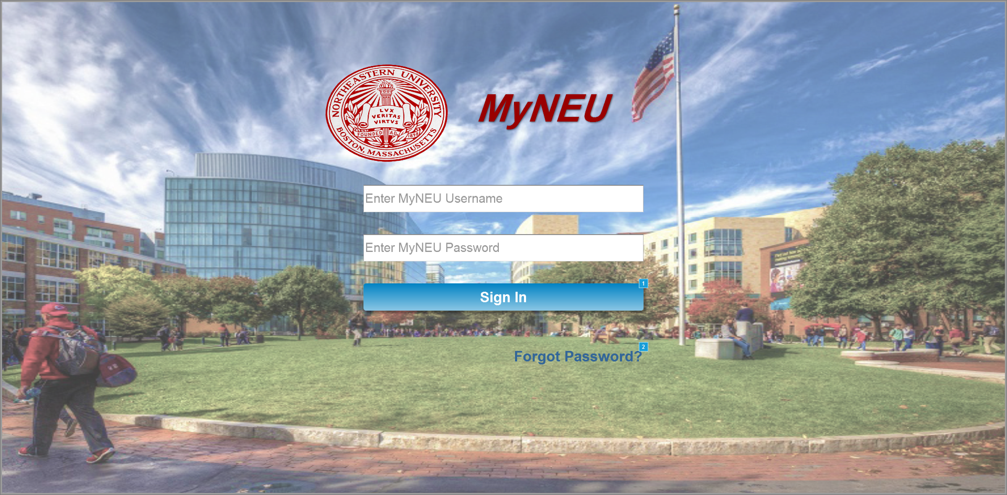

* + 1. Widget Table

|  |  |  |
| --- | --- | --- |
| Footnote | Name | Interactions |
| 1 | signInBtn | OnClick:  Case 1  (If text on usernameTxt equals ""):  Show userNameErr  Case 2  (Else If text on usernameTxt does not equal ""):  Hide userNameErr  Case 3  (If text on passwordTxt equals ""):  Show passwordErr  Case 4  (Else If text on passwordTxt does not equal ""):  Hide passwordErr  Case 5  (If text on usernameTxt equals "dandekar.v" and text on passwordTxt equals "12345"):  Set value of OnLoadVariable equal to "Vineet Dandekar"  Open Dashboard in Current Window  Case 6  (Else If text on usernameTxt does not equal "dandekar.v" and text on usernameTxt does not equal "" and text on passwordTxt does not equal "12345" and text on passwordTxt does not equal ""):  Show wrongCredentialErr |
| 2 |  | OnClick:  Case 1:  Open Forgot Password in Current Window |

* 1. Forgot Password
     1. User Interface

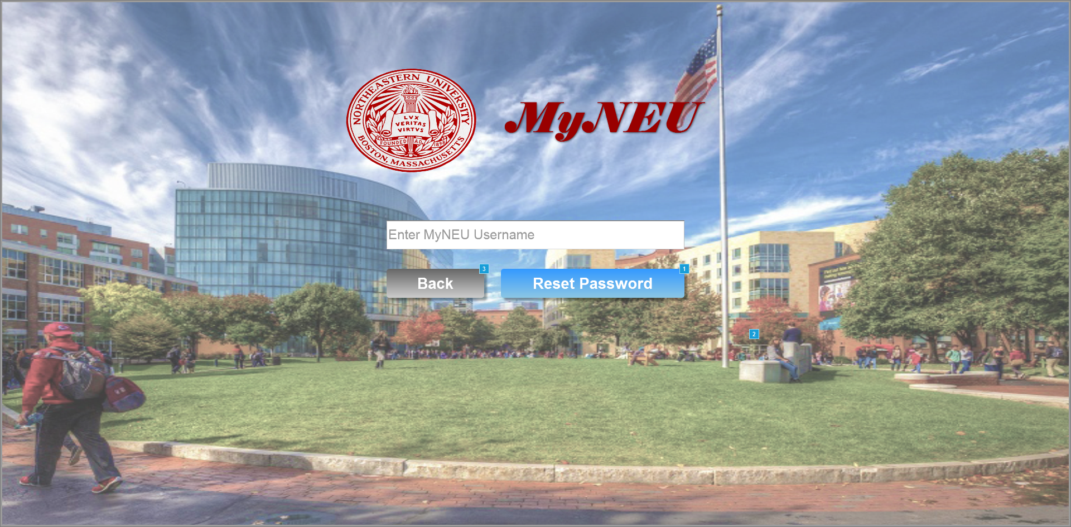

* + 1. Widget Table

|  |  |  |
| --- | --- | --- |
| Footnote | Name | Interactions |
| 1 | signInBtn | OnClick:  Case 1  (If text on usernameTxt equals ""):  Show userNameErr  Case 2  (Else If text on usernameTxt does not equal ""):  Show emailSendNotificationGrp  Hide userNameErr |
| 2 |  | OnClick:  Case 1:  Hide emailSendNotificationGrp |
| 3 | signInBtn | OnClick:  Case 1:  Open Login in Current Window |

* 1. Dashboard

OnPageLoad:  
 Case 1:  
 Set newsPnl to Next fade out 3000ms fade in 3000ms wrap repeat every 5000 ms delay first change

* + 1. User Interface

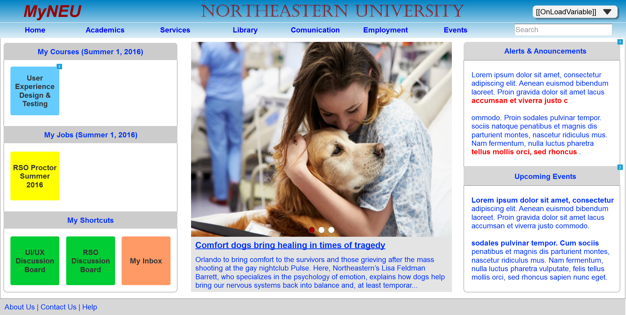

* + 1. Widget Table

|  |  |  |
| --- | --- | --- |
| Footnote | Name | Interactions |
| 1 | alertHeaderBox | OnClick:  Case 1:  Toggle alertBoxGrp push/pull widgets below |
| 2 | eventsHeaderBox | OnClick:  Case 1:  Toggle eventsBodyBox push/pull widgets below |
| 3 |  | OnClick:  Case 1:  Open Academics-Individual Course in Current Window |

* + 1. newsPnl
       1. News1
       2. User Interface



* + - 1. News2
      2. User Interface



* + - 1. News3
      2. User Interface



* 1. Library - My Account

OnPageLoad:  
 Case 1:  
 Hide successMsgGrp pull widgets below

* + 1. User Interface

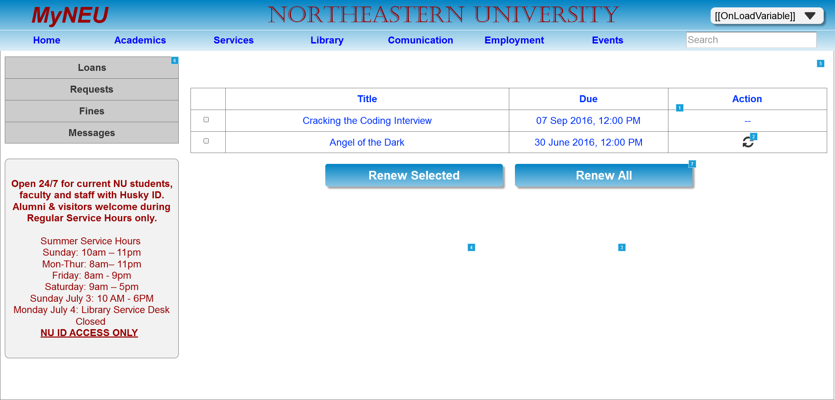

* + 1. Widget Table

|  |  |  |
| --- | --- | --- |
| Footnote | Name | Interactions |
| 1 |  | OnClick:  Case 1:  Hide confirmDialogGrp |
| 2 | renewIcon | OnClick:  Case 1:  Show confirmDialogGrp slide down 500 ms bring to front treat as lightbox |
| 3 | signInBtn | OnClick:  Case 1:  Hide confirmDialogGrp |
| 4 | signInBtn | OnClick:  Case 1:  Set text on dueDateCell equal to "30 Sep 2016, 12:00 PM", and  text on actionCell equal to "--"  Hide renewIcon, confirmDialogGrp  Show successMsgGrp |
| 5 |  | OnClick:  Case 1:  Hide successMsgGrp |
| 6 | loanSubMenuItem | OnClick:  Case 1:  Open Library - My Account in Current Window |
| 7 | signInBtn | OnClick:  Case 1:  Fire OnClick on renewIcon |

* 1. Library - Learning Material
     1. User Interface

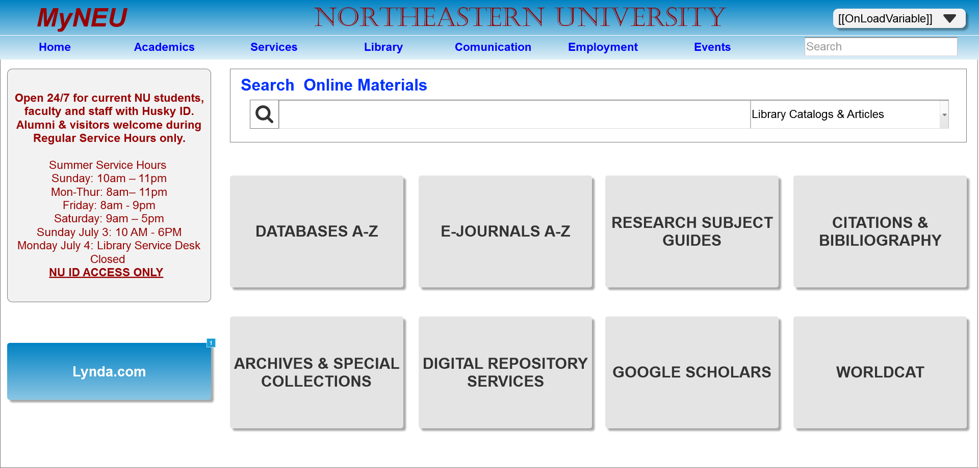

* + 1. Widget Table

|  |  |  |
| --- | --- | --- |
| Footnote | Name | Interactions |
| 1 | signInBtn | OnClick:  Case 1:  Open http://LYNDA.COM in New Window/Tab |

* 1. Library - Reserve a Room
     1. User Interface

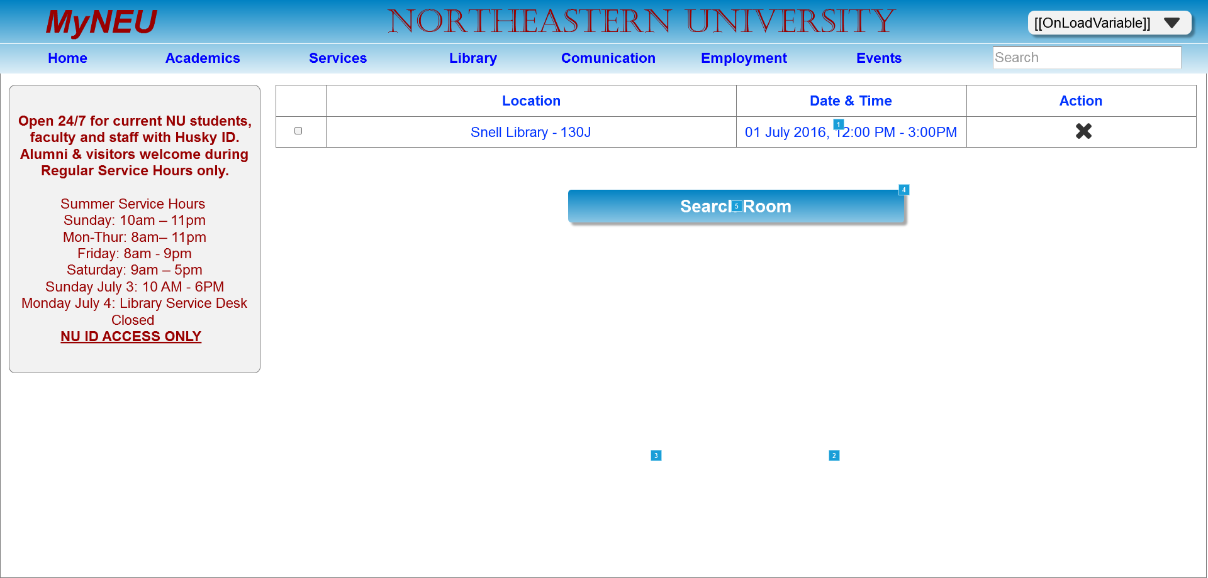

* + 1. Widget Table

|  |  |  |
| --- | --- | --- |
| Footnote | Name | Interactions |
| 1 |  | OnClick:  Case 1:  Hide confirmDialogGrp |
| 2 | signInBtn | OnClick:  Case 1:  Hide confirmDialogGrp |
| 3 | signInBtn | OnClick:  Case 1:  Hide confirmDialogGrp  Open Library - Search Room in Current Window |
| 4 | signInBtn | OnClick:  Case 1:  Show confirmDialogGrp slide down 500 ms bring to front treat as lightbox |
| 5 | button - date picker | OnClick:  show or hide calendar:  Toggle panel - calendar |

* + 1. panel - calendar
       1. November 2009
       2. User Interface

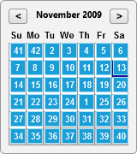

* + - 1. Widget Table

|  |  |
| --- | --- |
| Footnote | Interactions |
| 1 | OnClick:  Case 1:  Set text on textfield - date equal to "11/26/2009"  Hide panel - calendar |
| 2 | OnClick:  Case 1:  Set text on textfield - date equal to "11/3/2009"  Hide panel - calendar |
| 3 | OnClick:  Case 1:  Set text on textfield - date equal to "11/4/2009"  Hide panel - calendar |
| 4 | OnClick:  Case 1:  Set text on textfield - date equal to "11/5/2009"  Hide panel - calendar |
| 5 | OnClick:  Case 1:  Set text on textfield - date equal to "11/6/2009"  Hide panel - calendar |
| 6 | OnClick:  Case 1:  Set text on textfield - date equal to "11/7/2009"  Hide panel - calendar |
| 7 | OnClick:  Case 1:  Set text on textfield - date equal to "11/8/2009"  Hide panel - calendar |
| 8 | OnClick:  Case 1:  Set text on textfield - date equal to "11/9/2009"  Hide panel - calendar |
| 9 | OnClick:  Case 1:  Set text on textfield - date equal to "11/10/2009"  Hide panel - calendar |
| 10 | OnClick:  Case 1:  Set text on textfield - date equal to "11/11/2009"  Hide panel - calendar |
| 11 | OnClick:  Case 1:  Set text on textfield - date equal to "11/12/2009"  Hide panel - calendar |
| 12 | OnClick:  Case 1:  Set text on textfield - date equal to "11/13/2009"  Hide panel - calendar |
| 13 | OnClick:  Case 1:  Set text on textfield - date equal to "11/14/2009"  Hide panel - calendar |
| 14 | OnClick:  Case 1:  Set text on textfield - date equal to "11/15/2009"  Hide panel - calendar |
| 15 | OnClick:  Case 1:  Set text on textfield - date equal to "11/16/2009"  Hide panel - calendar |
| 16 | OnClick:  Case 1:  Set text on textfield - date equal to "11/17/2009"  Hide panel - calendar |
| 17 | OnClick:  Case 1:  Set text on textfield - date equal to "11/18/2009"  Hide panel - calendar |
| 18 | OnClick:  Case 1:  Set text on textfield - date equal to "11/19/2009"  Hide panel - calendar |
| 19 | OnClick:  Case 1:  Set text on textfield - date equal to "11/20/2009"  Hide panel - calendar |
| 20 | OnClick:  Case 1:  Set text on textfield - date equal to "11/21/2009"  Hide panel - calendar |
| 21 | OnClick:  Case 1:  Set text on textfield - date equal to "11/22/2009"  Hide panel - calendar |
| 22 | OnClick:  Case 1:  Set text on textfield - date equal to "11/23/2009"  Hide panel - calendar |
| 23 | OnClick:  Case 1:  Set text on textfield - date equal to "11/24/2009"  Hide panel - calendar |
| 24 | OnClick:  Case 1:  Set text on textfield - date equal to "11/25/2009"  Hide panel - calendar |
| 25 | OnClick:  Case 1:  Set text on textfield - date equal to "11/27/2009"  Hide panel - calendar |
| 26 | OnClick:  Case 1:  Set text on textfield - date equal to "11/28/2009"  Hide panel - calendar |
| 27 | OnClick:  Case 1:  Set text on textfield - date equal to "11/29/2009"  Hide panel - calendar |
| 28 | OnClick:  Case 1:  Set text on textfield - date equal to "11/30/2009"  Hide panel - calendar |
| 29 | OnClick:  Case 1:  Set text on textfield - date equal to "12/1/2009"  Hide panel - calendar |
| 30 | OnClick:  Case 1:  Set text on textfield - date equal to "12/2/2009"  Hide panel - calendar |
| 31 | OnClick:  Case 1:  Set text on textfield - date equal to "12/3/2009"  Hide panel - calendar |
| 32 | OnClick:  Case 1:  Set text on textfield - date equal to "12/4/2009"  Hide panel - calendar |
| 33 | OnClick:  Case 1:  Set text on textfield - date equal to "12/5/2009"  Hide panel - calendar |
| 34 | OnClick:  Case 1:  Set text on textfield - date equal to "12/6/2009"  Hide panel - calendar |
| 35 | OnClick:  Case 1:  Set text on textfield - date equal to "12/7/2009"  Hide panel - calendar |
| 36 | OnClick:  Case 1:  Set text on textfield - date equal to "12/8/2009"  Hide panel - calendar |
| 37 | OnClick:  Case 1:  Set text on textfield - date equal to "12/9/2009"  Hide panel - calendar |
| 38 | OnClick:  Case 1:  Set text on textfield - date equal to "12/10/2009"  Hide panel - calendar |
| 39 | OnClick:  Case 1:  Set text on textfield - date equal to "12/11/2009"  Hide panel - calendar |
| 40 | OnClick:  Case 1:  Set text on textfield - date equal to "12/12/2009"  Hide panel - calendar |
| 41 | OnClick:  Case 1:  Set text on textfield - date equal to "11/1/2009"  Hide panel - calendar |
| 42 | OnClick:  Case 1:  Set text on textfield - date equal to "11/2/2009"  Hide panel - calendar |

* 1. Library - Search Room
     1. User Interface

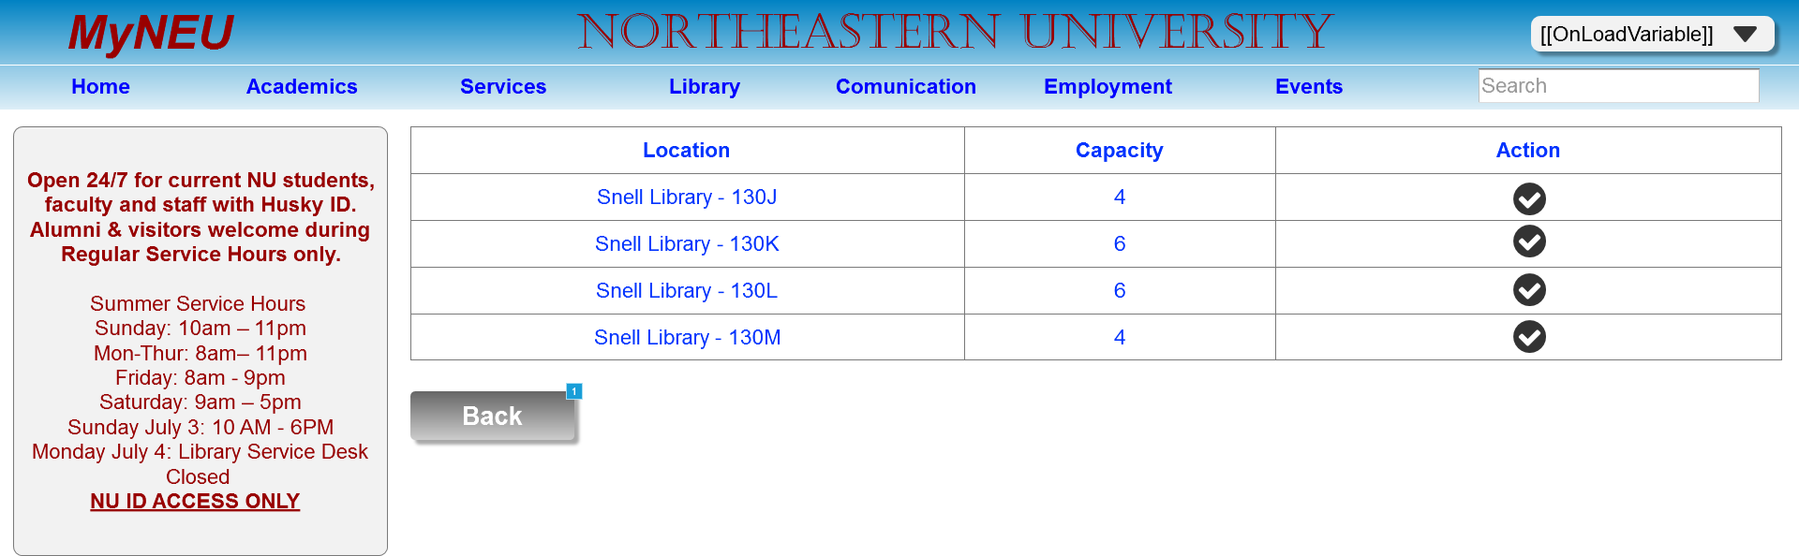

* + 1. Widget Table

|  |  |  |
| --- | --- | --- |
| Footnote | Name | Interactions |
| 1 | signInBtn | OnClick:  Case 1:  Open Library - Reserve a Room in Current Window |

* 1. Academics-MyGrades
     1. User Interface

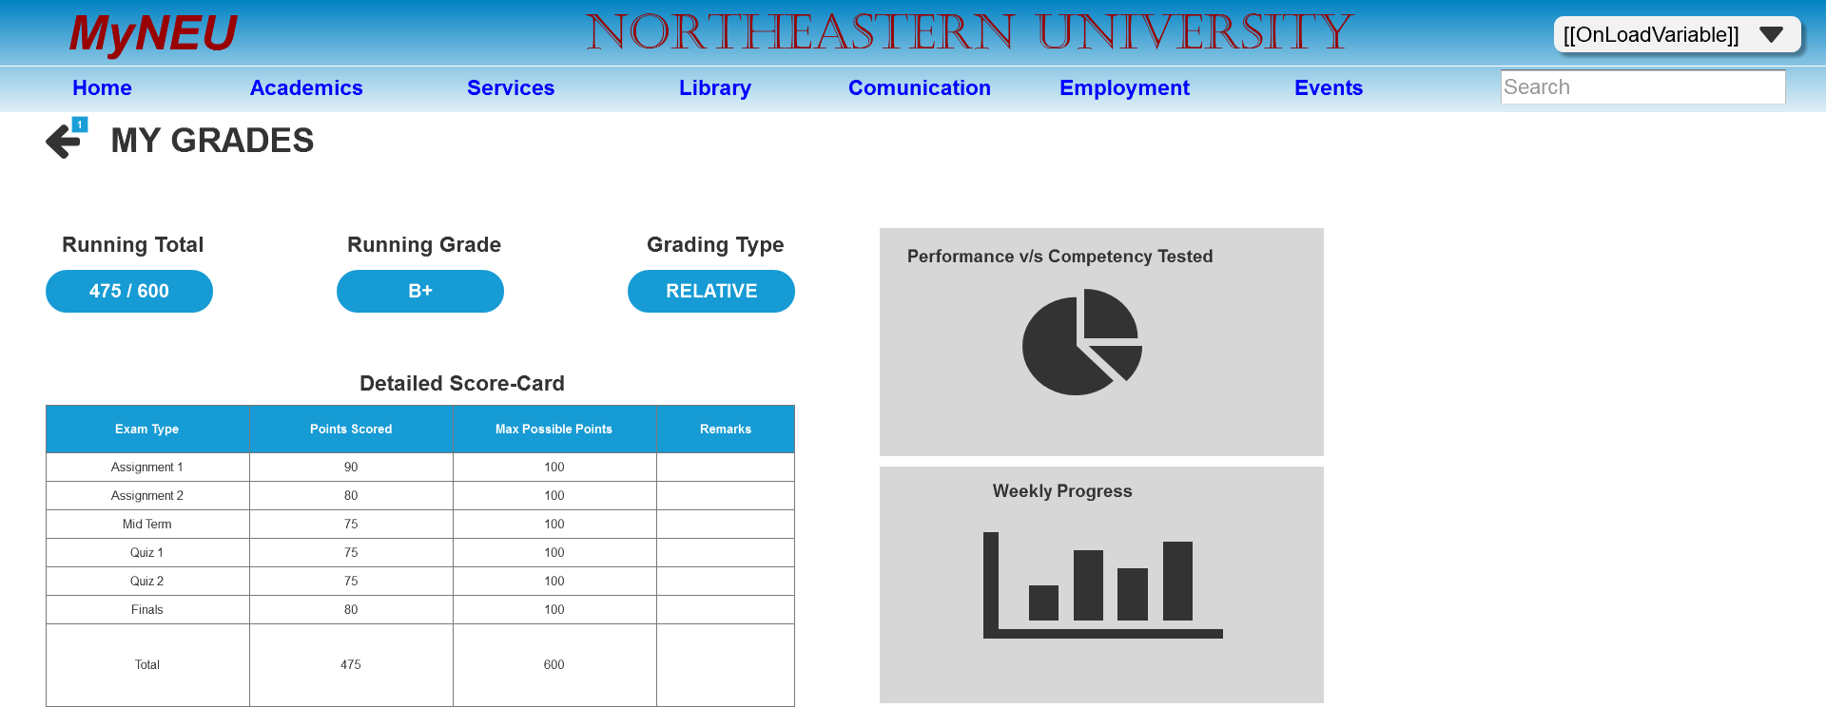

* + 1. Widget Table

|  |  |
| --- | --- |
| Footnote | Interactions |
| 1 | OnClick:  Case 1:  Open Academics-Individual Course in Current Window |

* 1. Academics-MyCourses
     1. User Interface

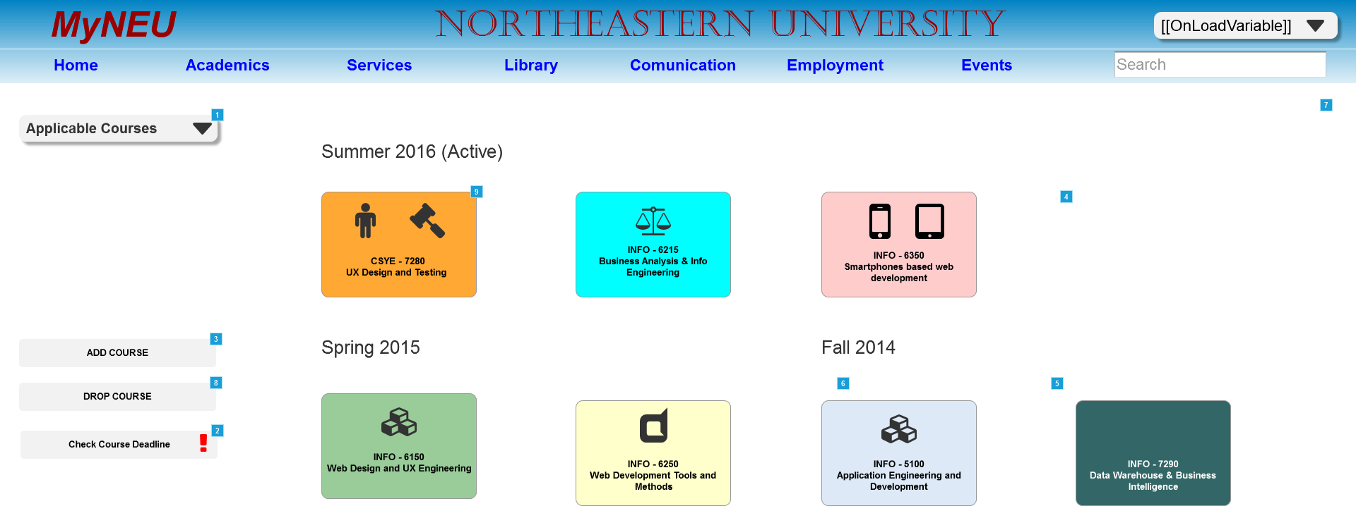

* + 1. Widget Table

|  |  |  |
| --- | --- | --- |
| Footnote | Name | Interactions |
| 1 | headerComboboxGrp | OnClick:  Case 1:  Toggle menuItemsGrp OnLostFocus:  Case 1:  Hide menuItemsGrp |
| 2 |  | OnClick:  Case 1:  Toggle CourseDeadlineNoticeGroup push/pull widgets below |
| 3 |  | OnClick:  Case 1:  Show dialogBoxGrp slide up 500 ms bring to front treat as lightbox |
| 4 |  | OnClick:  Case 1:  Show/Hide Widget |
| 5 | signInBtn | OnClick:  Case 1:  Hide dialogBoxGrp |
| 6 | signInBtn | OnClick:  Case 1:  Hide dialogBoxGrp  Show successMsgGrp |
| 7 |  | OnClick:  Case 1:  Hide successMsgGrp |
| 8 |  | OnClick:  Case 1:  Hide successMsgGrp pull widgets below |
| 9 | UXCourseTileGrp | OnClick:  Case 1:  Open Academics-Individual Course in Current Window |

* 1. Academics-Individual Course

OnPageLoad:  
 Case 1:  
 Set Announcements to Next slide down out 500ms slide up in 500ms wrap repeat every 1000 ms delay first change

* + 1. User Interface

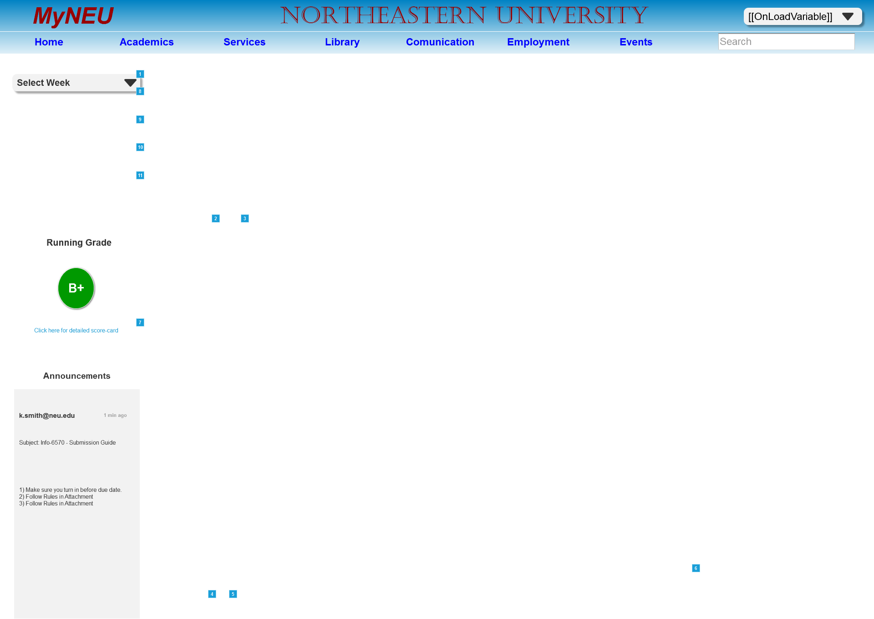

* + 1. Widget Table

|  |  |  |
| --- | --- | --- |
| Footnote | Name | Interactions |
| 1 | headerComboboxGrp | OnClick:  Case 1:  Toggle menuItemsGrp OnLostFocus:  Case 1:  Hide menuItemsGrp |
| 2 | playIcon_RM | OnClick:  Case 1:  Set ReadingMaterial to Next slide up out 500ms slide up in 500ms wrap repeat every 1000 ms delay first change |
| 3 |  | OnClick:  Case 1:  Set ReadingMaterial to stop repeating |
| 4 | playIcon_RM | OnClick:  Case 1:  Set assignmentQuestions to Next wrap repeat every 1000 ms delay first change |
| 5 |  | OnClick:  Case 1:  Set assignmentQuestions to stop repeating |
| 6 | placeholder | OnClick:  Case 1:  Toggle popoutStuff push/pull widgets below |
| 7 | link | OnClick:  Case 1:  Open Academics-MyGrades in Current Window |
| 8 | profileMenuGrp | OnClick:  Case 1:  Show CompleteRightPaneContentGrp slide right 500 ms |
| 9 | profileMenuGrp | OnClick:  Case 1:  Show CompleteRightPaneContentGrp slide right 500 ms |
| 10 | emailMenuGrp | OnClick:  Case 1:  Show CompleteRightPaneContentGrp slide right 500 ms |
| 11 | logoutMenuGrp | OnClick:  Case 1:  Show CompleteRightPaneContentGrp flip right 500 ms |

* + 1. Youtube player
       1. State1
       2. User Interface

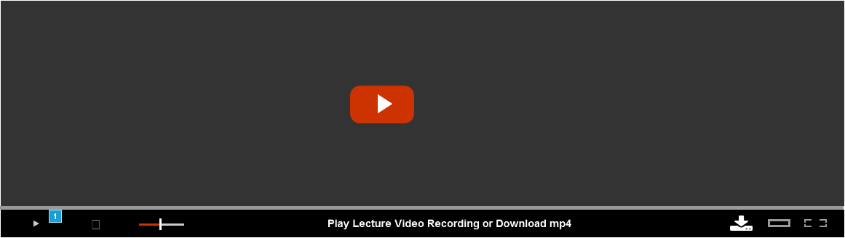

* + - 1. Widget Table

|  |  |  |
| --- | --- | --- |
| Footnote | Name | Interactions |
| 1 |  | OnClick:  Case 1  (If state of Play Pause btn1 equals State1):  Hide Youtube play icon fade 200 ms  Set Play Pause btn1 to State2 show if hidden  Set Media fill to State2 slide right in 3000ms show if hidden  Wait 3000 ms  Set Play Pause btn1 to State1 show if hidden  Set Media fill to State1 show if hidden  Show Youtube play icon fade 200 ms |

* + 1. Media fill
       1. State1
       2. State2
       3. User Interface



* + 1. Play Pause btn1
       1. State1
       2. User Interface



* + - 1. State2
      2. User Interface



* + 1. Youtube play icon
       1. State1
       2. User Interface



* + - 1. Widget Table

|  |  |
| --- | --- |
| Footnote | Interactions |
| 1 | OnClick:  Case 1:  Hide Youtube play icon fade 200 ms  Set Play Pause btn1 to State2 show if hidden  Set Media fill to State2 slide right in 3000ms show if hidden  Wait 3000 ms  Set Play Pause btn1 to State1 show if hidden  Set Media fill to State1 show if hidden  Show Youtube play icon fade 200 ms |
| 2 | OnClick:  Case 1:  Hide Youtube play icon fade 200 ms  Set Play Pause btn1 to State2 show if hidden  Set Media fill to State2 slide right in 3000ms show if hidden  Wait 3000 ms  Set Play Pause btn1 to State1 show if hidden  Set Media fill to State1 show if hidden  Show Youtube play icon fade 200 ms |

* + 1. Volume view window
       1. State1
       2. User Interface



* + - 1. Widget Table

|  |  |  |
| --- | --- | --- |
| Footnote | Name | Interactions |
| 1 | Volume handle | OnDrag:  Case 1  (If area of volume handler is over area of BackgroundZone):  Move Volume handle with drag x OnDragDrop:  Case 1  (If area of Volume handle is over area of endZone):  Move Volume handle to (-14,0) linear 100ms  Case 1  (Else If area of Volume handle is over area of StartZone):  Move Volume handle to (-73,0) linear 100ms |

* + 1. Volume handle
       1. State1
       2. User Interface



* + 1. ReadingMaterial
       1. State1
       2. User Interface

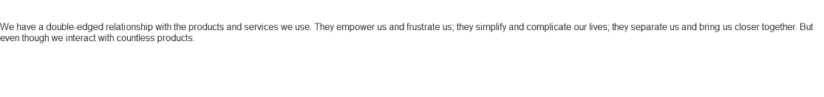

* + - 1. State2
      2. User Interface

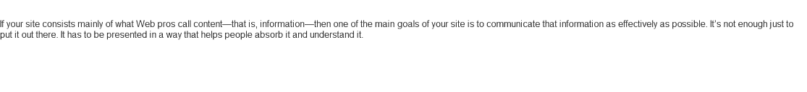

* + - 1. State3
      2. User Interface

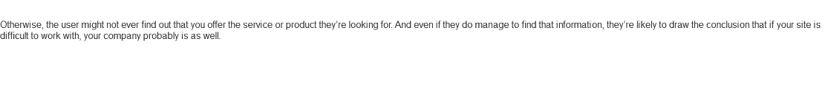

* + 1. assignmentQuestions
       1. State1
       2. User Interface



* + - 1. State2
      2. User Interface



* + 1. Announcements
       1. State1
       2. User Interface

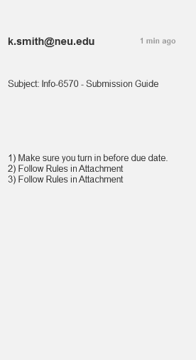

* + - 1. State2
      2. User Interface



* + - 1. State3
      2. User Interface

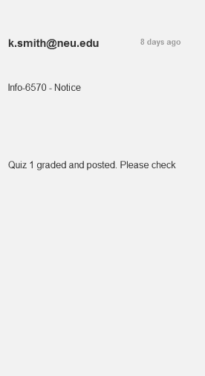

* + - 1. State4
      2. User Interface

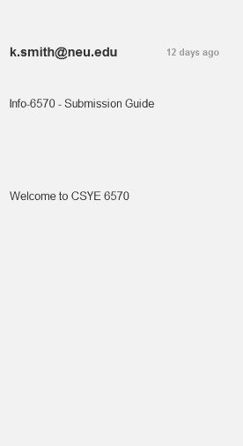

* 1. Academics-Transcripts
     1. User Interface



* 1. Services-Parking
     1. User Interface

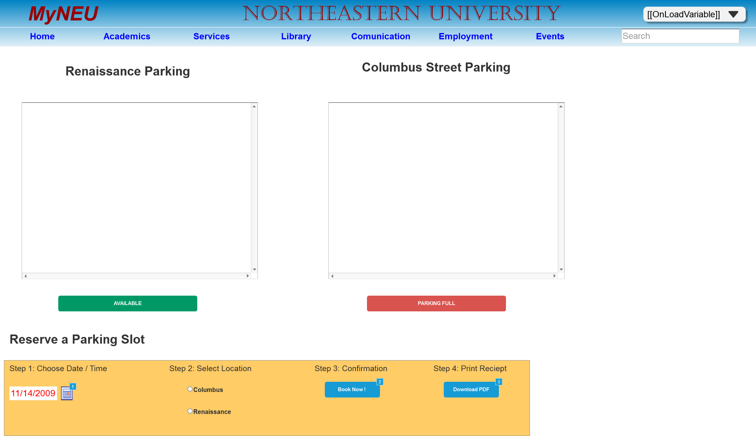

* + 1. Widget Table

|  |  |  |
| --- | --- | --- |
| Footnote | Name | Interactions |
| 1 | button - date picker | OnClick:  show or hide calendar:  Toggle panel - calendar |
| 2 |  | OnClick:  Case 1:  Toggle (Group) push/pull widgets below |
| 3 |  | OnClick:  Case 1:  Toggle (Group) push/pull widgets below |

* + 1. panel - calendar
       1. November 2009
       2. User Interface



* + - 1. Widget Table

|  |  |
| --- | --- |
| Footnote | Interactions |
| 1 | OnClick:  Case 1:  Set text on textfield - date equal to "11/26/2009"  Hide panel - calendar |
| 2 | OnClick:  Case 1:  Set text on textfield - date equal to "11/3/2009"  Hide panel - calendar |
| 3 | OnClick:  Case 1:  Set text on textfield - date equal to "11/4/2009"  Hide panel - calendar |
| 4 | OnClick:  Case 1:  Set text on textfield - date equal to "11/5/2009"  Hide panel - calendar |
| 5 | OnClick:  Case 1:  Set text on textfield - date equal to "11/6/2009"  Hide panel - calendar |
| 6 | OnClick:  Case 1:  Set text on textfield - date equal to "11/7/2009"  Hide panel - calendar |
| 7 | OnClick:  Case 1:  Set text on textfield - date equal to "11/8/2009"  Hide panel - calendar |
| 8 | OnClick:  Case 1:  Set text on textfield - date equal to "11/9/2009"  Hide panel - calendar |
| 9 | OnClick:  Case 1:  Set text on textfield - date equal to "11/10/2009"  Hide panel - calendar |
| 10 | OnClick:  Case 1:  Set text on textfield - date equal to "11/11/2009"  Hide panel - calendar |
| 11 | OnClick:  Case 1:  Set text on textfield - date equal to "11/12/2009"  Hide panel - calendar |
| 12 | OnClick:  Case 1:  Set text on textfield - date equal to "11/13/2009"  Hide panel - calendar |
| 13 | OnClick:  Case 1:  Set text on textfield - date equal to "11/14/2009"  Hide panel - calendar |
| 14 | OnClick:  Case 1:  Set text on textfield - date equal to "11/15/2009"  Hide panel - calendar |
| 15 | OnClick:  Case 1:  Set text on textfield - date equal to "11/16/2009"  Hide panel - calendar |
| 16 | OnClick:  Case 1:  Set text on textfield - date equal to "11/17/2009"  Hide panel - calendar |
| 17 | OnClick:  Case 1:  Set text on textfield - date equal to "11/18/2009"  Hide panel - calendar |
| 18 | OnClick:  Case 1:  Set text on textfield - date equal to "11/19/2009"  Hide panel - calendar |
| 19 | OnClick:  Case 1:  Set text on textfield - date equal to "11/20/2009"  Hide panel - calendar |
| 20 | OnClick:  Case 1:  Set text on textfield - date equal to "11/21/2009"  Hide panel - calendar |
| 21 | OnClick:  Case 1:  Set text on textfield - date equal to "11/22/2009"  Hide panel - calendar |
| 22 | OnClick:  Case 1:  Set text on textfield - date equal to "11/23/2009"  Hide panel - calendar |
| 23 | OnClick:  Case 1:  Set text on textfield - date equal to "11/24/2009"  Hide panel - calendar |
| 24 | OnClick:  Case 1:  Set text on textfield - date equal to "11/25/2009"  Hide panel - calendar |
| 25 | OnClick:  Case 1:  Set text on textfield - date equal to "11/27/2009"  Hide panel - calendar |
| 26 | OnClick:  Case 1:  Set text on textfield - date equal to "11/28/2009"  Hide panel - calendar |
| 27 | OnClick:  Case 1:  Set text on textfield - date equal to "11/29/2009"  Hide panel - calendar |
| 28 | OnClick:  Case 1:  Set text on textfield - date equal to "11/30/2009"  Hide panel - calendar |
| 29 | OnClick:  Case 1:  Set text on textfield - date equal to "12/1/2009"  Hide panel - calendar |
| 30 | OnClick:  Case 1:  Set text on textfield - date equal to "12/2/2009"  Hide panel - calendar |
| 31 | OnClick:  Case 1:  Set text on textfield - date equal to "12/3/2009"  Hide panel - calendar |
| 32 | OnClick:  Case 1:  Set text on textfield - date equal to "12/4/2009"  Hide panel - calendar |
| 33 | OnClick:  Case 1:  Set text on textfield - date equal to "12/5/2009"  Hide panel - calendar |
| 34 | OnClick:  Case 1:  Set text on textfield - date equal to "12/6/2009"  Hide panel - calendar |
| 35 | OnClick:  Case 1:  Set text on textfield - date equal to "12/7/2009"  Hide panel - calendar |
| 36 | OnClick:  Case 1:  Set text on textfield - date equal to "12/8/2009"  Hide panel - calendar |
| 37 | OnClick:  Case 1:  Set text on textfield - date equal to "12/9/2009"  Hide panel - calendar |
| 38 | OnClick:  Case 1:  Set text on textfield - date equal to "12/10/2009"  Hide panel - calendar |
| 39 | OnClick:  Case 1:  Set text on textfield - date equal to "12/11/2009"  Hide panel - calendar |
| 40 | OnClick:  Case 1:  Set text on textfield - date equal to "12/12/2009"  Hide panel - calendar |
| 41 | OnClick:  Case 1:  Set text on textfield - date equal to "11/1/2009"  Hide panel - calendar |
| 42 | OnClick:  Case 1:  Set text on textfield - date equal to "11/2/2009"  Hide panel - calendar |

* 1. Services-Finance
     1. User Interface



* 1. Services-HealthAppointment

OnPageLoad:  
 Case 1:  
 Show/Hide Widget

* + 1. User Interface

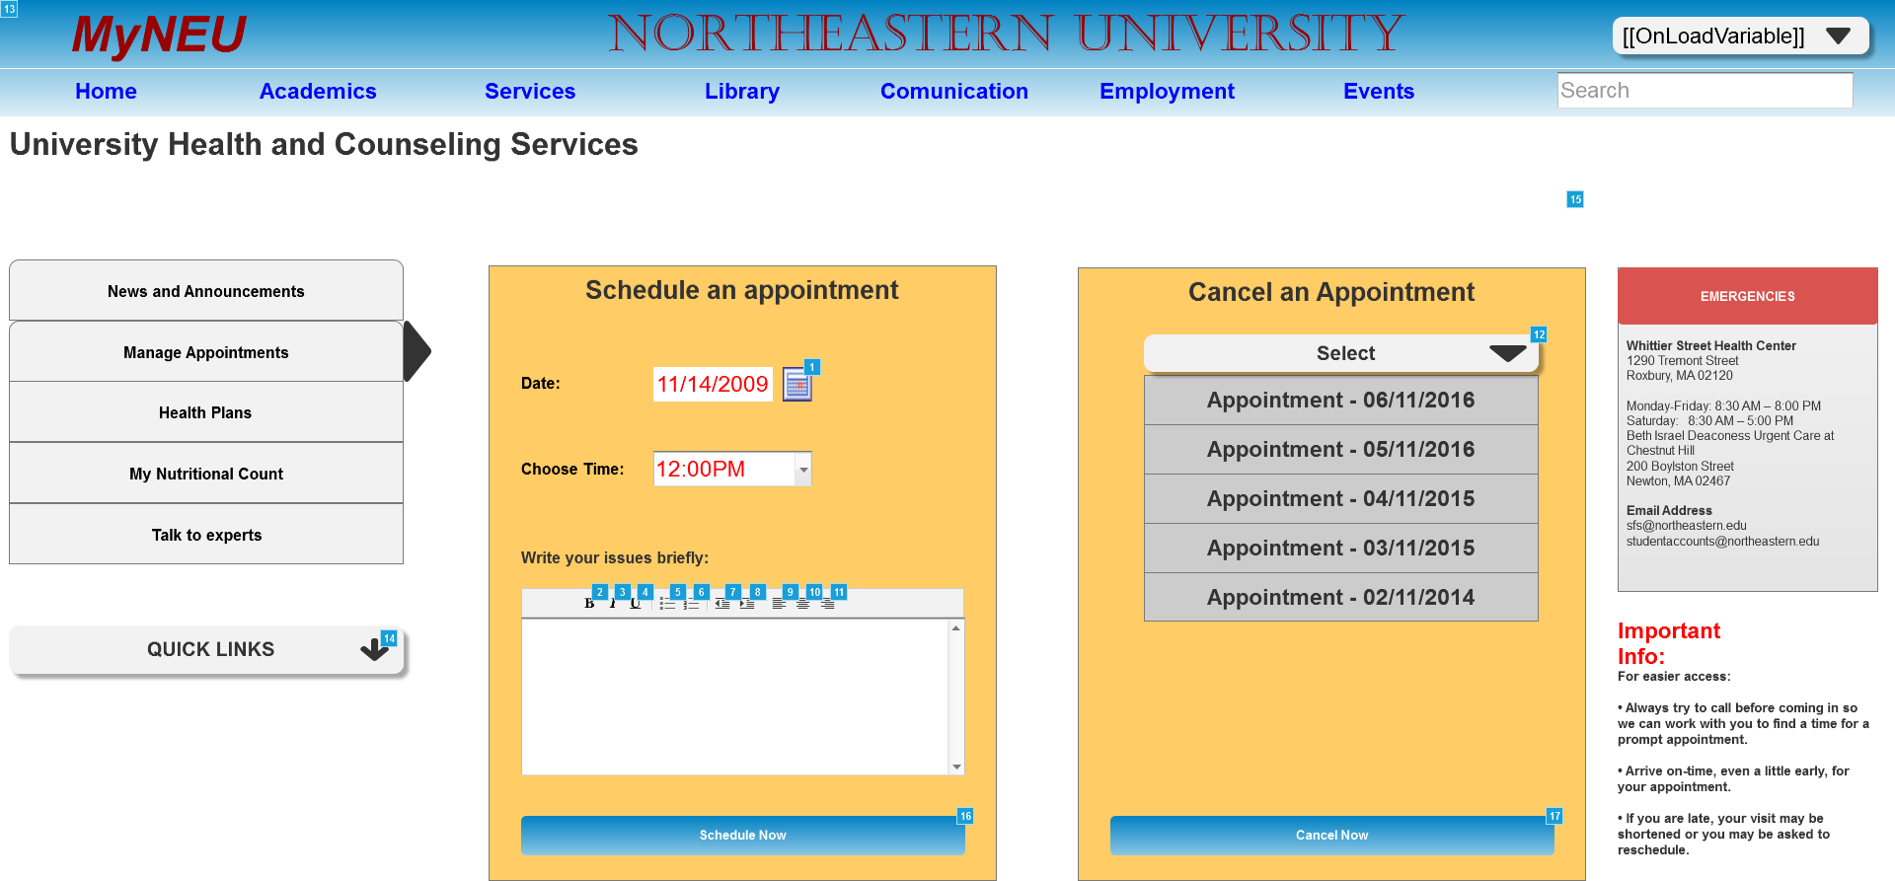

* + 1. Widget Table

|  |  |  |
| --- | --- | --- |
| Footnote | Name | Interactions |
| 1 | button - date picker | OnClick:  show or hide calendar:  Toggle panel - calendar |
| 2 | textarea button - bold | OnClick:  toggle bold:  Set is selected of textarea button - bold equal to "toggle"  Set Focus on textarea |
| 3 | textarea button - italic | OnClick:  toggle italic:  Set is selected of textarea button - italic equal to "toggle"  Set Focus on textarea |
| 4 | textarea button - underline | OnClick:  toggle underline:  Set is selected of textarea button - underline equal to "toggle"  Set Focus on textarea |
| 5 | textarea button - unordered list | OnClick:  toggle unordered list:  Set is selected of textarea button - unordered list equal to "toggle", and  is selected of textarea button - ordered list equal to "false"  Set Focus on textarea |
| 6 | textarea button - ordered list | OnClick:  toggle ordered list:  Set is selected of textarea button - ordered list equal to "toggle", and  is selected of textarea button - unordered list equal to "false"  Set Focus on textarea |
| 7 | textarea button - outdent | OnClick:  outdent:  Set Focus on textarea |
| 8 | textarea button - indent | OnClick:  indent:  Set Focus on textarea |
| 9 | textarea button - align left | OnClick:  set left align:  Set is selected of textarea button - align left equal to "true", and  is selected of textarea button - align right equal to "false", and  is selected of textarea button - align center equal to "false"  Set Focus on textarea |
| 10 | textarea button - align center | OnClick:  set center align:  Set is selected of textarea button - align left equal to "false", and  is selected of textarea button - align right equal to "false", and  is selected of textarea button - align center equal to "true"  Set Focus on textarea |
| 11 | textarea button - align right | OnClick:  set right align:  Set is selected of textarea button - align left equal to "false", and  is selected of textarea button - align right equal to "true", and  is selected of textarea button - align center equal to "false"  Set Focus on textarea |
| 12 | headerComboboxGrp | OnClick:  Case 1:  Show/Hide Widget OnLostFocus:  Case 1:  Show/Hide Widget |
| 13 | headerComboboxGrp | OnClick:  Case 1:  Show/Hide Widget OnLostFocus:  Case 1:  Show/Hide Widget |
| 14 |  | OnClick:  Case 1:  Toggle quickLinksTable push/pull widgets below |
| 15 |  | OnClick:  Case 1:  Hide successMsgGrp |
| 16 |  | OnClick:  Case 1:  Show successMsgGrp bring to front push widgets below  Set text on textarea equal to "" |
| 17 |  | OnClick:  Case 1:  Hide successMsgGrp pull widgets below |

* + 1. panel - calendar
       1. November 2009
       2. User Interface



* + - 1. Widget Table

|  |  |
| --- | --- |
| Footnote | Interactions |
| 1 | OnClick:  Case 1:  Set text on textfield - date equal to "11/26/2009"  Hide panel - calendar |
| 2 | OnClick:  Case 1:  Set text on textfield - date equal to "11/3/2009"  Hide panel - calendar |
| 3 | OnClick:  Case 1:  Set text on textfield - date equal to "11/4/2009"  Hide panel - calendar |
| 4 | OnClick:  Case 1:  Set text on textfield - date equal to "11/5/2009"  Hide panel - calendar |
| 5 | OnClick:  Case 1:  Set text on textfield - date equal to "11/6/2009"  Hide panel - calendar |
| 6 | OnClick:  Case 1:  Set text on textfield - date equal to "11/7/2009"  Hide panel - calendar |
| 7 | OnClick:  Case 1:  Set text on textfield - date equal to "11/8/2009"  Hide panel - calendar |
| 8 | OnClick:  Case 1:  Set text on textfield - date equal to "11/9/2009"  Hide panel - calendar |
| 9 | OnClick:  Case 1:  Set text on textfield - date equal to "11/10/2009"  Hide panel - calendar |
| 10 | OnClick:  Case 1:  Set text on textfield - date equal to "11/11/2009"  Hide panel - calendar |
| 11 | OnClick:  Case 1:  Set text on textfield - date equal to "11/12/2009"  Hide panel - calendar |
| 12 | OnClick:  Case 1:  Set text on textfield - date equal to "11/13/2009"  Hide panel - calendar |
| 13 | OnClick:  Case 1:  Set text on textfield - date equal to "11/14/2009"  Hide panel - calendar |
| 14 | OnClick:  Case 1:  Set text on textfield - date equal to "11/15/2009"  Hide panel - calendar |
| 15 | OnClick:  Case 1:  Set text on textfield - date equal to "11/16/2009"  Hide panel - calendar |
| 16 | OnClick:  Case 1:  Set text on textfield - date equal to "11/17/2009"  Hide panel - calendar |
| 17 | OnClick:  Case 1:  Set text on textfield - date equal to "11/18/2009"  Hide panel - calendar |
| 18 | OnClick:  Case 1:  Set text on textfield - date equal to "11/19/2009"  Hide panel - calendar |
| 19 | OnClick:  Case 1:  Set text on textfield - date equal to "11/20/2009"  Hide panel - calendar |
| 20 | OnClick:  Case 1:  Set text on textfield - date equal to "11/21/2009"  Hide panel - calendar |
| 21 | OnClick:  Case 1:  Set text on textfield - date equal to "11/22/2009"  Hide panel - calendar |
| 22 | OnClick:  Case 1:  Set text on textfield - date equal to "11/23/2009"  Hide panel - calendar |
| 23 | OnClick:  Case 1:  Set text on textfield - date equal to "11/24/2009"  Hide panel - calendar |
| 24 | OnClick:  Case 1:  Set text on textfield - date equal to "11/25/2009"  Hide panel - calendar |
| 25 | OnClick:  Case 1:  Set text on textfield - date equal to "11/27/2009"  Hide panel - calendar |
| 26 | OnClick:  Case 1:  Set text on textfield - date equal to "11/28/2009"  Hide panel - calendar |
| 27 | OnClick:  Case 1:  Set text on textfield - date equal to "11/29/2009"  Hide panel - calendar |
| 28 | OnClick:  Case 1:  Set text on textfield - date equal to "11/30/2009"  Hide panel - calendar |
| 29 | OnClick:  Case 1:  Set text on textfield - date equal to "12/1/2009"  Hide panel - calendar |
| 30 | OnClick:  Case 1:  Set text on textfield - date equal to "12/2/2009"  Hide panel - calendar |
| 31 | OnClick:  Case 1:  Set text on textfield - date equal to "12/3/2009"  Hide panel - calendar |
| 32 | OnClick:  Case 1:  Set text on textfield - date equal to "12/4/2009"  Hide panel - calendar |
| 33 | OnClick:  Case 1:  Set text on textfield - date equal to "12/5/2009"  Hide panel - calendar |
| 34 | OnClick:  Case 1:  Set text on textfield - date equal to "12/6/2009"  Hide panel - calendar |
| 35 | OnClick:  Case 1:  Set text on textfield - date equal to "12/7/2009"  Hide panel - calendar |
| 36 | OnClick:  Case 1:  Set text on textfield - date equal to "12/8/2009"  Hide panel - calendar |
| 37 | OnClick:  Case 1:  Set text on textfield - date equal to "12/9/2009"  Hide panel - calendar |
| 38 | OnClick:  Case 1:  Set text on textfield - date equal to "12/10/2009"  Hide panel - calendar |
| 39 | OnClick:  Case 1:  Set text on textfield - date equal to "12/11/2009"  Hide panel - calendar |
| 40 | OnClick:  Case 1:  Set text on textfield - date equal to "12/12/2009"  Hide panel - calendar |
| 41 | OnClick:  Case 1:  Set text on textfield - date equal to "11/1/2009"  Hide panel - calendar |
| 42 | OnClick:  Case 1:  Set text on textfield - date equal to "11/2/2009"  Hide panel - calendar |

* 1. Dashboard v2

OnPageLoad:  
 Case 1:  
 Set newsPnl to Next slide left out 500ms slide left in 500ms wrap repeat every 5000 ms delay first change

* + 1. User Interface

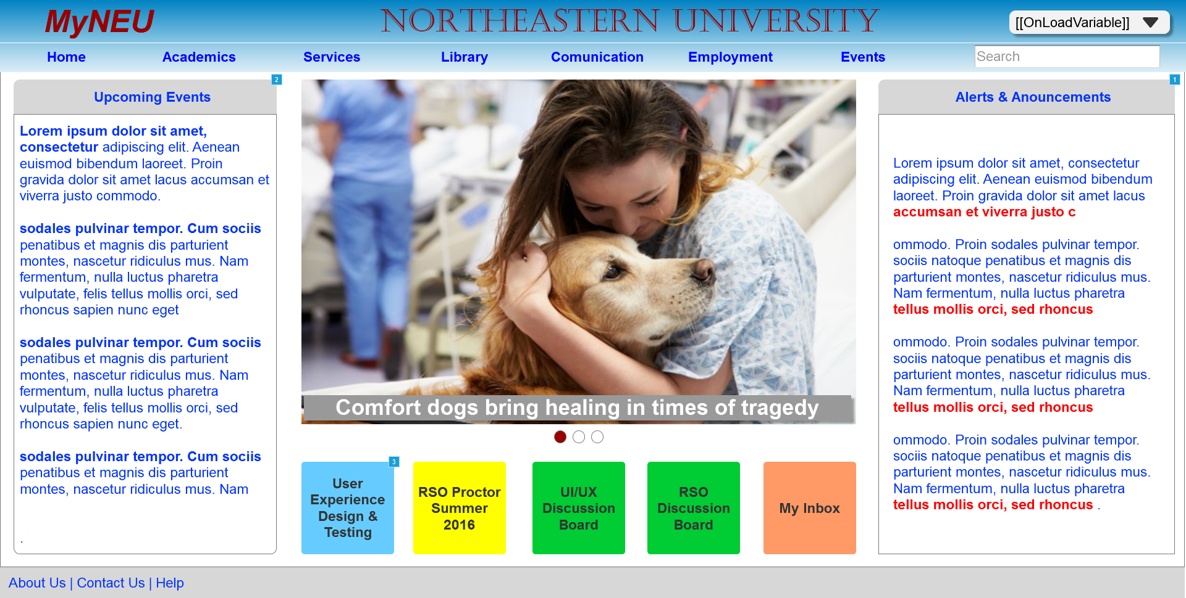

* + 1. Widget Table

|  |  |  |
| --- | --- | --- |
| Footnote | Name | Interactions |
| 1 | alertHeaderBox | OnClick:  Case 1: |
| 2 | eventsHeaderBox | OnClick:  Case 1: |
| 3 |  | OnClick:  Case 1:  Open Academics-Individual Course in Current Window |

* + 1. newsPnl
       1. News1
       2. User Interface



* + - 1. News2
      2. User Interface



* + - 1. News3
      2. User Interface



* 1. Page 3
     1. User Interface



1. Masters
   1. Master List

Header  
Main Menu  
Submit Button  
Footer  
Tile  
Back Button  
SearchRoomDialog

* 1. Header

OnPageLoad:  
 Case 1:  
 Set text on (Rectangle) equal to "[[OnLoadVariable]]"

* + 1. User Interface



* + 1. Widget Table

|  |  |  |
| --- | --- | --- |
| Footnote | Name | Interactions |
| 1 | headerComboboxGrp | OnClick:  Case 1:  Toggle menuItemsGrp OnLoad:  Case 1:  Set text on (Rectangle) equal to value of OnLoadVariable OnLostFocus:  Case 1:  Hide menuItemsGrp |
| 2 |  | OnClick:  Case 1:  Open Dashboard in Current Window |
| 3 | logoutMenuGrp | OnClick:  Case 1:  Open Login in Current Window  Set value of OnLoadVariable equal to "" |

* 1. Main Menu
     1. User Interface



Menu Object

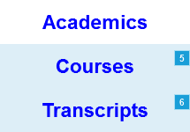 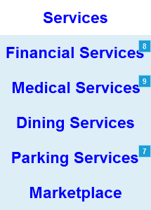 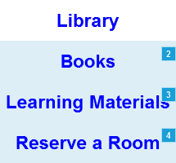 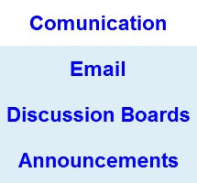 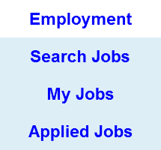 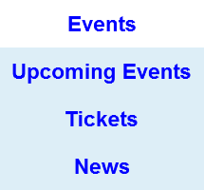

* + 1. Widget Table

|  |  |  |
| --- | --- | --- |
| Footnote | Name | Interactions |
| 1 |  | OnClick:  Case 1:  Open Dashboard in Current Window |
| 2 |  | OnClick:  Case 1:  Open Library - My Account in Current Window |
| 3 |  | OnClick:  Case 1:  Open Library - Learning Material in Current Window |
| 4 |  | OnClick:  Case 1:  Open Library - Reserve a Room in Current Window |
| 5 | Courses | OnClick:  Case 1:  Open Academics-MyCourses in Current Window |
| 6 |  | OnClick:  Case 1:  Open Academics-Transcripts in Current Window |
| 7 |  | OnClick:  Case 1:  Open Services-Parking in Current Window |
| 8 |  | OnClick:  Case 1:  Open Services-Finance in Current Window |
| 9 |  | OnClick:  Case 1:  Open Services-HealthAppointment in Current Window |

* 1. Submit Button
     1. User Interface



* 1. Footer
     1. User Interface



* 1. Tile
     1. User Interface

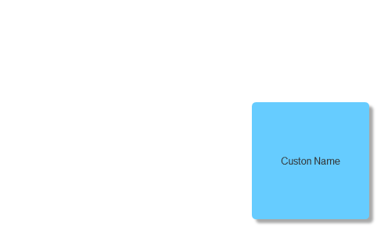

* 1. Back Button
     1. User Interface

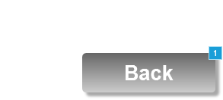

* + 1. Widget Table

|  |  |  |
| --- | --- | --- |
| Footnote | Name | Interactions |
| 1 | signInBtn | OnClick:  Case 1:  Open Login in Current Window |

* 1. SearchRoomDialog
     1. User Interface

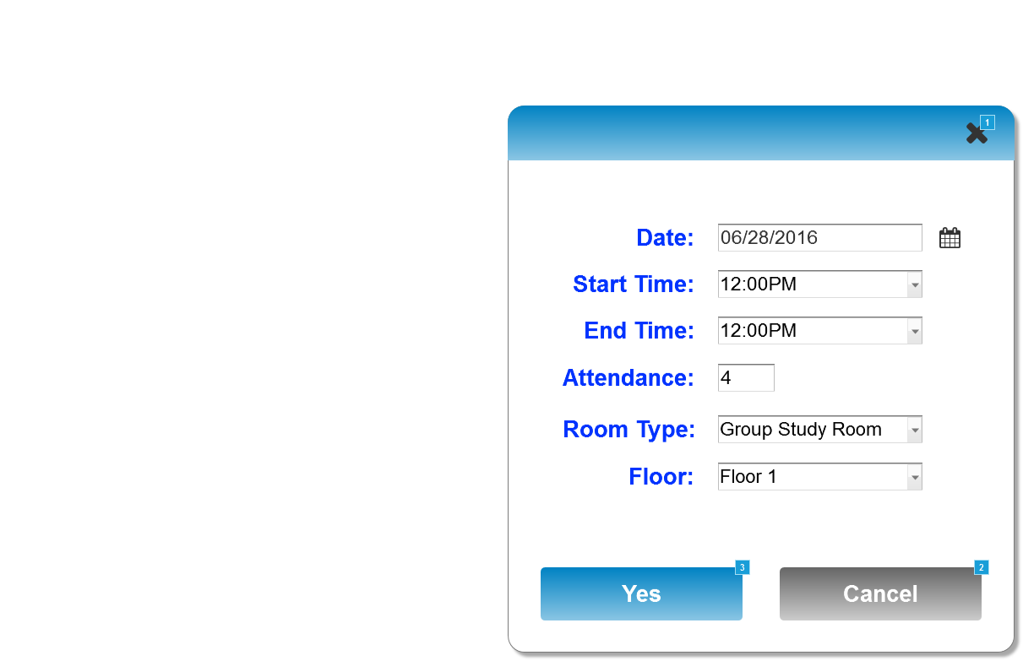

* + 1. Widget Table

|  |  |  |
| --- | --- | --- |
| Footnote | Name | Interactions |
| 1 |  | OnClick:  Case 1:  Hide confirmDialogGrp |
| 2 | signInBtn | OnClick:  Case 1:  Hide confirmDialogGrp |
| 3 | signInBtn | OnClick:  Case 1:  Set text on Unidentified equal to "30 Sep 2016, 12:00 PM", and  text on Unidentified equal to "--"  Hide confirmDialogGrp  Show/Hide Widget |